1. 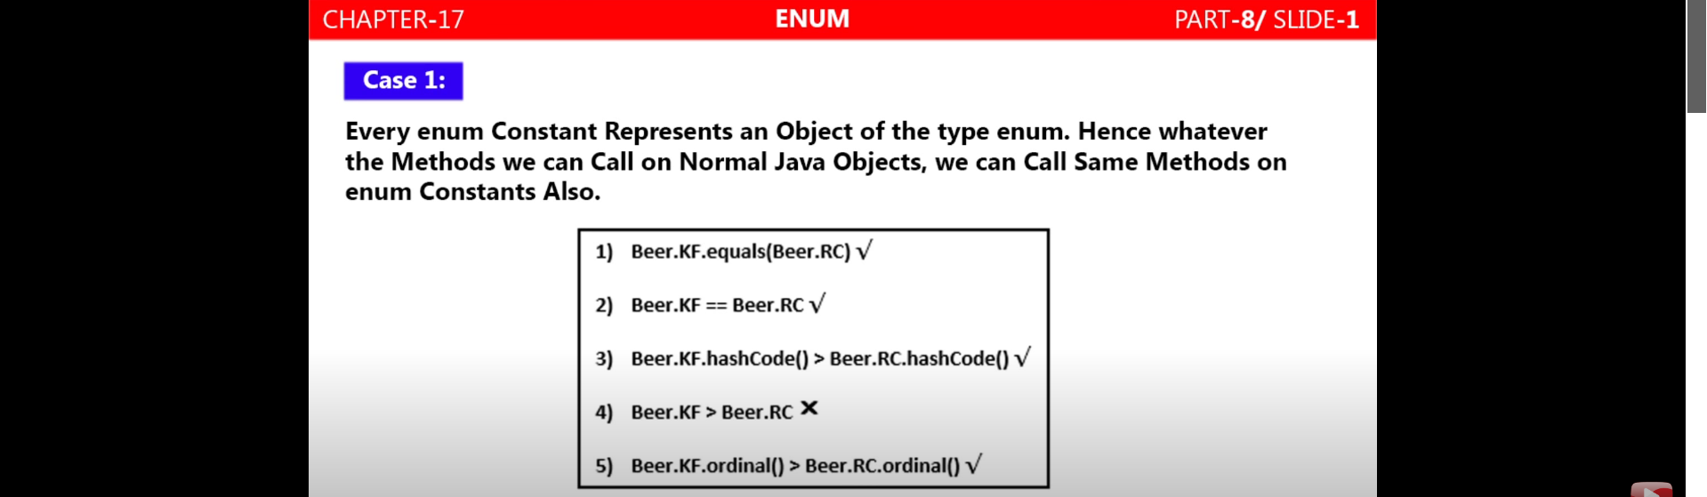
2. Static import came in 1.5V.
3. **If accessing Enum class name somehow, then normal import**. Like  
   Beer bear = Beer.KF; Or  
   sop(Beer.KF)  
   **If accessing only Enum named Constant, then just static import will work** like   
   sop(KF);   
   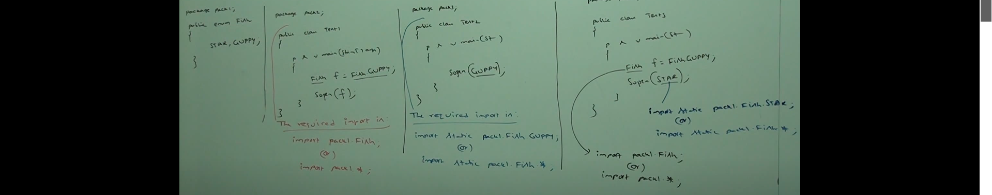
4. 